AUTH-007
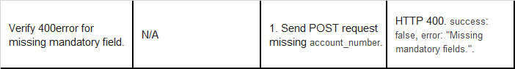
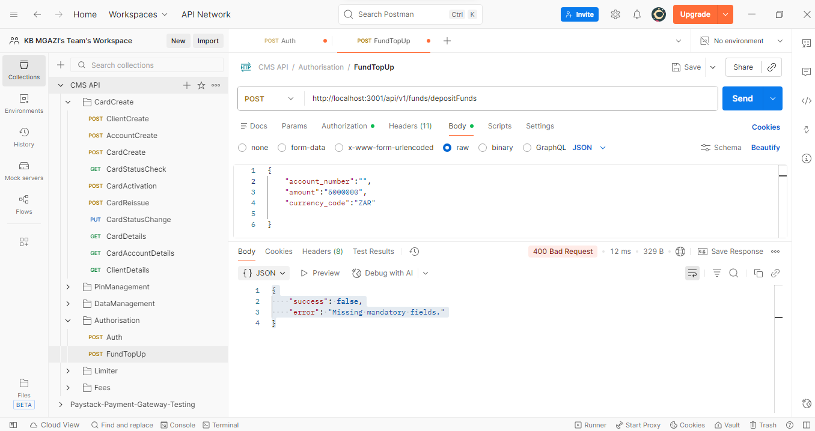
Request:
{
"account_number":"",
"amount":"5000000",
"currency_code":"ZAR"

}
Response:
{
"success": false,
"error": "Missing mandatory fields."
}

